Process report
GROUP A
Student name: Student number
Georgi Chishirkov [2530090]
Ilia Nikushev [2551721]
Yu Hong [2598515]

Date : 1.2.2016

Version: final

Contents:
Introduce: 1
Group part: 1
Decisions and explanation: 1
Division: 2
Record of meeting: 2
Individual part: 3
Georgi Chishirkov: 3
Ilia Nikushev: 3
Yu Hong: 3

Introduction:
In this process report document we will show how our group worked together and how each individual benefited from the project by showing: decisions we have made, division of work, problems and solutions, individual’s opinion and the brief record of meetings.

Group:
Our group members are Georgi Chishirkov, Ilia Nikushev and Yu Hong. Together we have completed documents and code.

Decisions and explanation:
- We created dictionary to define the phases.
Explanation: Make a definition of phases is helpful to understand what the certain element is and which is used in each step.

- User positions over 2 or more overlapping pipeline to delete: System highlights the last created one.
Explanation: Ensure users do not delete the pipeline they do not want.

- Move element outside the panel: Elements remain in the panel.
Explanation: Elements for the pipeline cannot exist outside of the panel.

- Move element on top of another element: Element back to last known position.
Explanation: Two elements cannot be at the on top of another

- Create a pipe connection between two elements, that already are connected
Explanation: Users cannot create other connections between elements that already have influence on the system.

- Users change the flow of pipeline to a negative number: System sets it 0.
Explanation: The flow cannot be beneath 0.

- User creates or loads a new pipeline when there is unsaved changes: Users are prompted if they want to save.
Explanation: Ensure users will not lose the effort if miss-click or miss-operate.

- Right click menu lose focus: System closes menu.
Explanation: Once the menu is out of focus, the user no longer has interest

- We add two extra functions: redo and undo.
Explanation: Guarantees a more error-free environment, where the user can make mistakes.

- For nonfunctional requirements, we aim at usability, stability, performance and extensibility.
Explanation: Program will be easy and intuitive to use and ensure everything will run as fast as possible and new feature will be easily accepted.

- The position of an element is considered from top left corner of the drawing panel.
Explanation: To clarify what the position of an element is.

- Remove Daniel from the team.
Explanation: His contribution and knowledge was not sufficient enough.

Division:
See Appendix 1

Record of meeting:
We explain the decisions in documents and answer the questions which are not been fully understood at that moment. After getting feedback, agreements have been made which are basically in the aspects of improving the diction, thorough consideration of conditions.

Following are the understandings and agreements:
- Make a dictionary to help users understand the elements used in program.
- Add more alternatives to specify more conditions.
- Explain more of nonfunctional requirements.

Individual part:

Georgi Chishirkov:
Problems:

Personal view:

Ilia Nikushev:
Problems:
Distribution of work amongst team members. Not everybody has the same knowledge level or time to spend on the project, or willingness.
Personal view:
This project baffled me with the amount of optimization that is required to make Windows Forms responsive. It is a time consuming task.
Other than that, the project did not yield any new knowledge to me, code wise.
The documentation requirements are not correctly laid out. Not every project needs a class diagram with many details, or sequence diagrams that show everything. A simpler approach is better than having every single detail. A good programmer can work with little, but descriptive enough.
The whole problem with the documentation is that the URS require use cases, which in some term are sequence diagrams.

Yu Hong:
Problems:
Struggled with coding a bit at the beginning because of trying to understand the code’s structure. Endeavoring to cooperate group well since i am at another class having different schedule.
Personal view:
I may not contribute as much as others’ to this project, but still have learned something in the aspect of coding.
I get inspired to simplify the code if there are the codes effecting the the same function, consider the speed of codes working which is at the stage of “have a thought and give a try” so far but will be developed. Besides, ability of understanding code have been improved as well.
The deficiency i got in this project is not being active enough. I ought take more and complete more tasks.
I will be appreciated if the amount of documentation work could be decreased. We can find several analogues in three documents. After all it is a programming project.

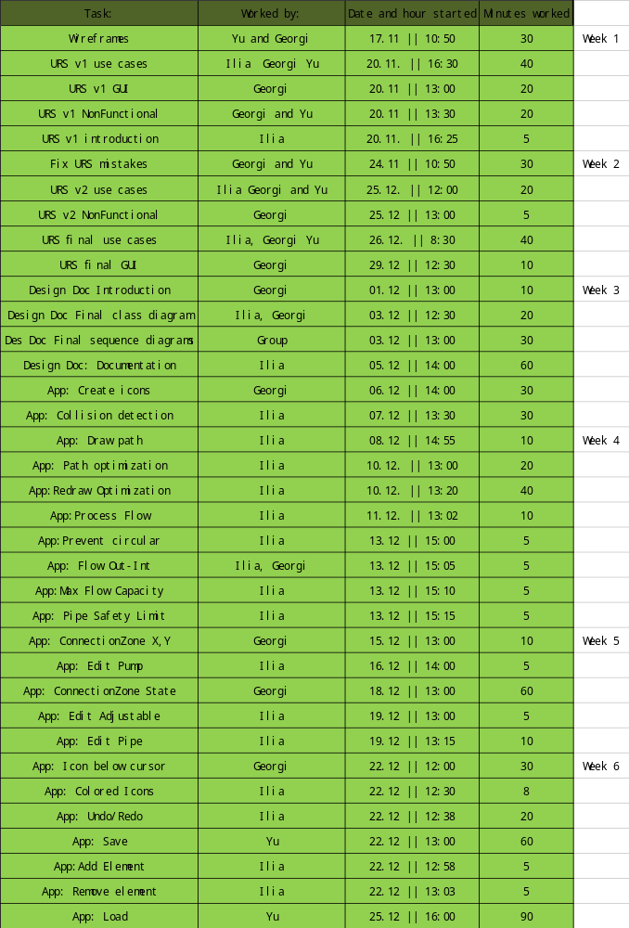Appendix 1

